Cell Mediated Immunity
Norma Gloria Laurel

The formation of T cells that are actively engaged in cell-mediated immune responses is achieve through an extensive process of differentiation. First, the stem cell in the bone marrow undergo differentiation into T cells that respond to antigens. This is called antigen independent differentiation and takes in the thymus. The mature antigen responsive T cells are activated by antigen and differentiate into functional effector cells (Th, Td, Tc and Ts cells). The secondary differentiation takes place ins secondary lymphoid organs
Antigen-Independent Differentiation
The initial differentiation of T cells go through two phases both of which do not require antigen. The differentiation is influenced by the environment of the bone marrow. The stem cells in the bone marrow undergo differentiation into T cell precursors and take up residence in the thymus.
T Cell Subsets
Approximately 65% of mature T cells that leave the thymus display the CD2+CD3+CD4+CD8- phenotype (CD4+ cells), while approximately 35% display the CD2+CD3+CD4-CD8+ phenotype (CD8+ cells).
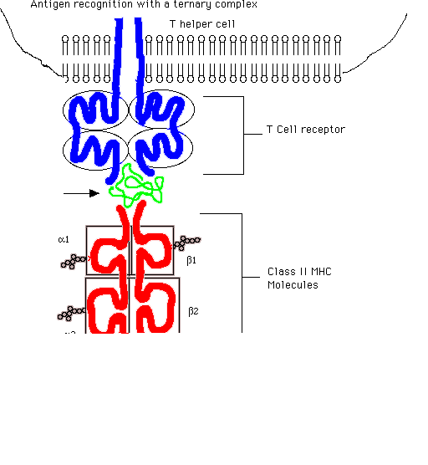
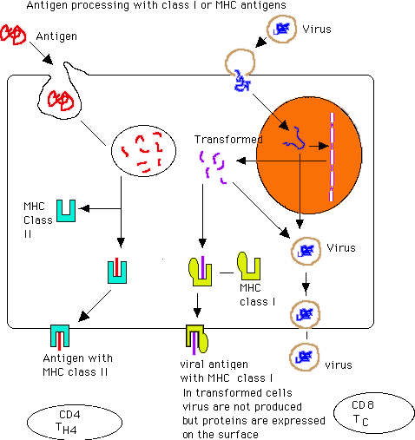
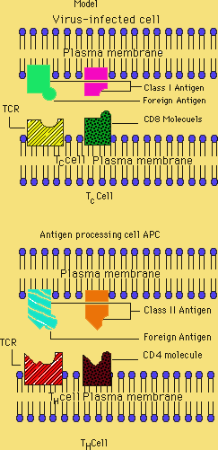
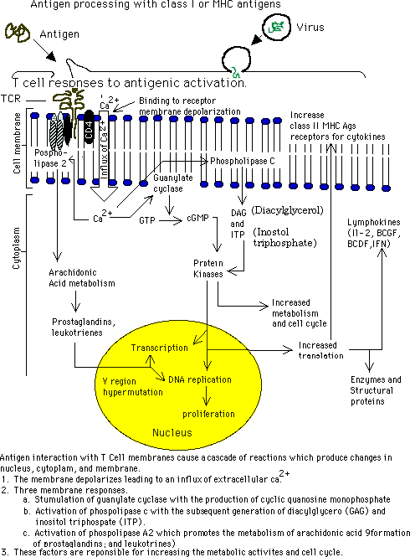
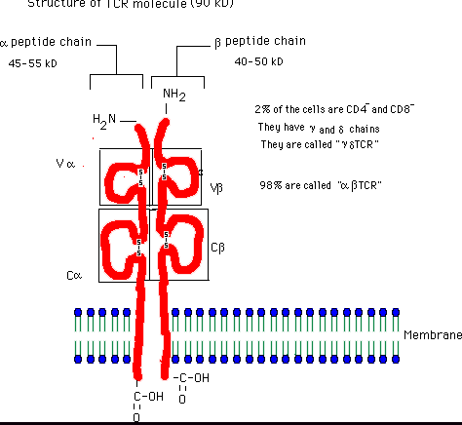
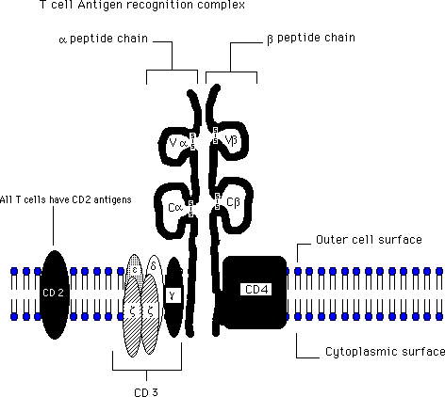
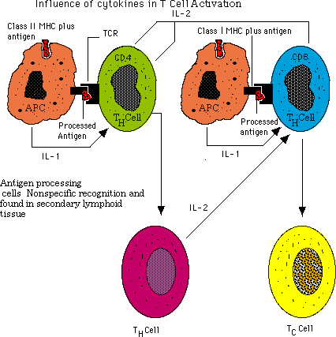
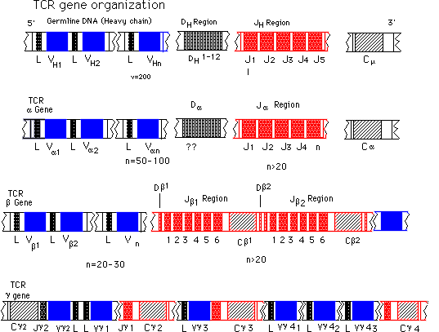
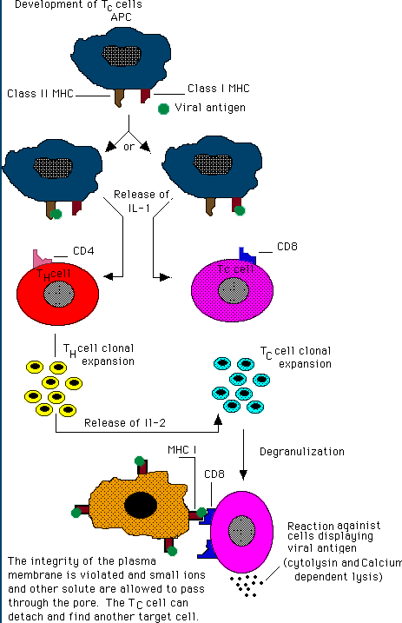
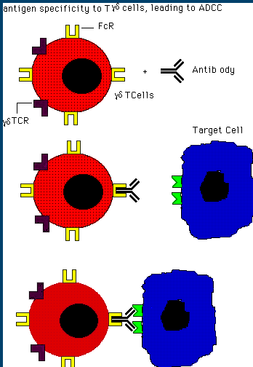
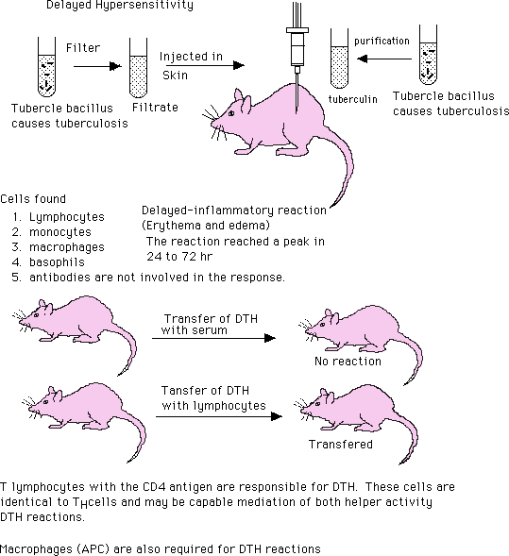

Return
This page is maintained by the Natural Toxins Research Center at Texas A&M University - Kingsville.

