Nonspecific Immunity

Immunity is mediated by humoral and cellular effectors. Certain immune responses are antigen specific. They are provoked by unique determinants of the antigens and effectors produce antibodies or T cells which are antigen specific. This requires selection of effectors of appropriate specificity for clonal expansion before an effective response can be observed. In contrast, other immune responses can be evoked by infectious agents or injury in a generalized, antigen nonspecific manner. These responses are not induced by unique determinants. In addition, the effectors produced recognize conserved, rather than unique, determinants.
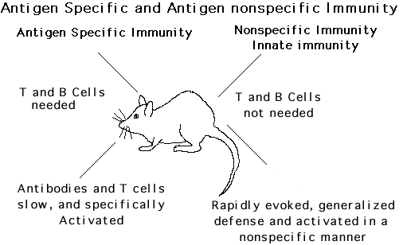
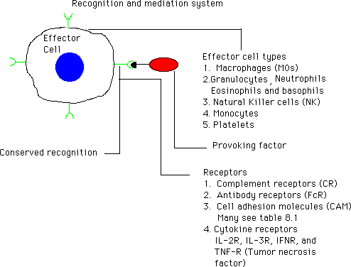
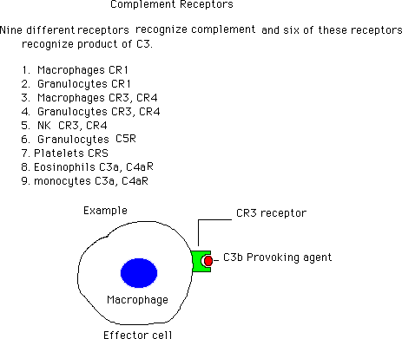
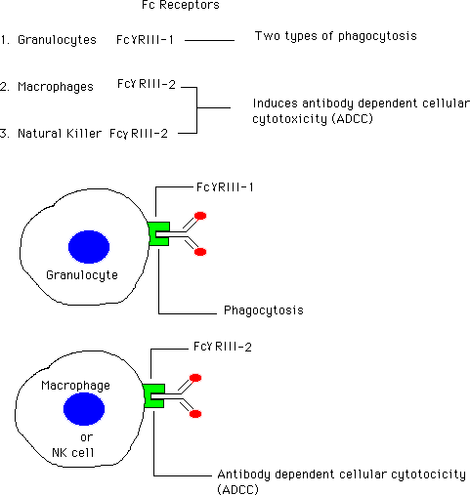
Cell adhesion molecules (CAM)
Cell adhesion molecules (CAM) represent a diverse group of surface antigens that are used for ligand specific attachment.
Cell adhesion molecules (CAM) have three major functions.
1. Adhesion of cells to vascular endothelium
2. Chemotatic guidance
3. Attachment and stabilization in target cell.
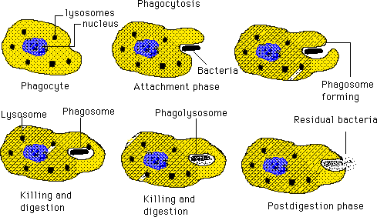
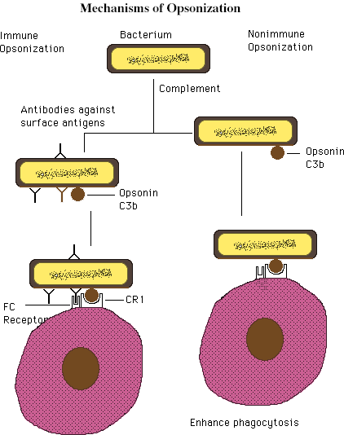
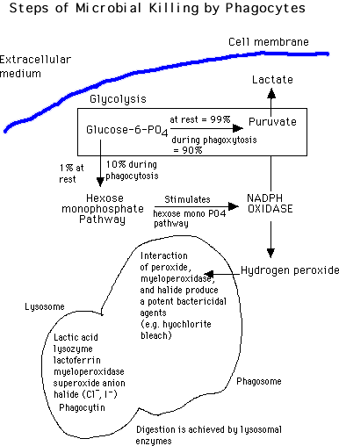
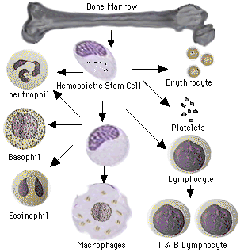
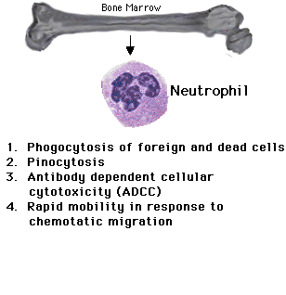
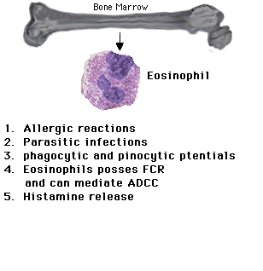
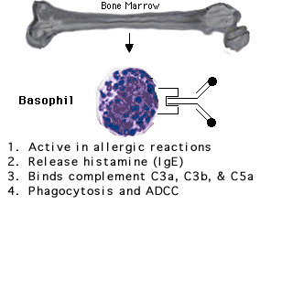
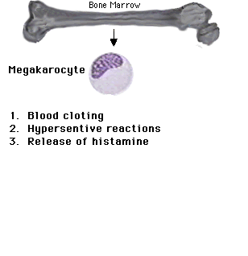
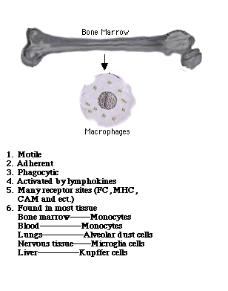
Inflammatory Responses
1. Redness (Increase blood flow) vessels dilate.
2. Heat (Increase blood flow) vesseks dilate.
Transudate (0.2% protein)
Exudate (5% protein)
Serous exudate (no cells)
Purulent exudate (rich in cells manily neutrophils)
Hemorrhagic exudate (blood)
Fibrinous exudate (fibrin)
3. Swelling (Increase vasular permeability)
4. Pain
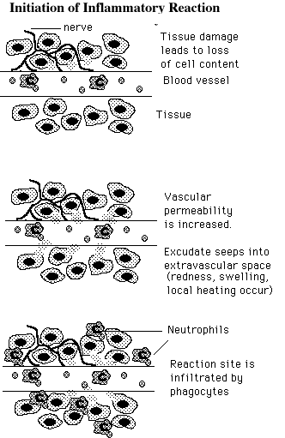
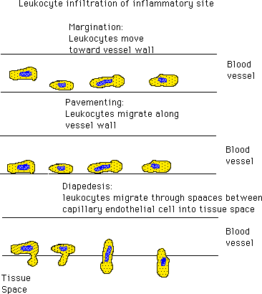
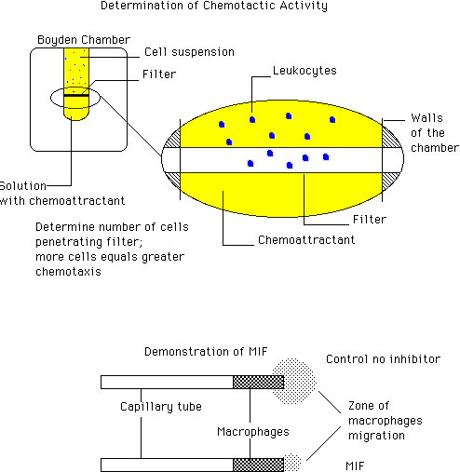
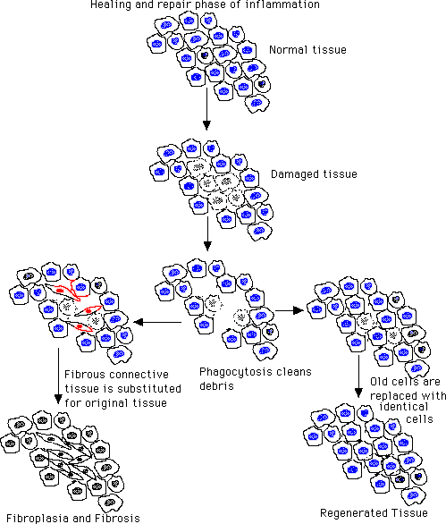

Return
This page is maintained by the Natural Toxins Research Center at Texas A&M University - Kingsville.

