Acquired Immune Deficiency Syndrome

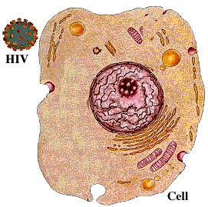

Return
This page is maintained by the Natural Toxins Research Center at Texas A&M University - Kingsville.

