Humoral Response
Miguel Perez III

Antigens
An antigen (Ag) can be defined as any foreign molecule that will stimulate antibody (Ab) formation when injected into vertebrate host. The new formed antibody will react (bind) specifically to the immunizing antigen. Antigen can be defined more broadly as any substance that can bind to specific antibody molecule or specific antigen receptors on lymphocytes. A distinct site (epitope) on the antigen can react with an antigen binding site (paratope) on the antibody.
Types of Antigens
- Soluble and cell-bound proteins constitute the largest group of naturally occurring antigens.
- In addition polysaccharides, lipids and nucleic acids (often associated with proteins) are also antigenic.
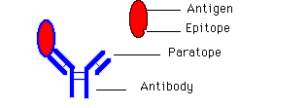
Complete antigens are multideterminant which posses several epitopes. Generally, there is one epitope for every molecular weight of 10,000 daltons. An antigen with a molecular weigh of 60,000 can have six different epitopes and react with six different paratopes and different antibodies. There can be as many different species of antibodies (or effector T cell clones) produced as there are functional epitopes on an antigen.
Hapten
An incomplete antigen (hapten) is a chemically defined substance of low molecular weight that cannot induce an adaptive immune response by itself. The hapten can react with the paratope on an antibody. Haptens can produce antibodies if they are conjugated to larger carrier molecule (normally proteins). Haptens contain a single epitope. The hapten is too small to engage T and B cells simultaneously. If the hapten is conjugated to a carrier protein, a T cell recognizes epitopes of this protein and a B cell recognizes the hapten. Antihapten antibodies are produce as well as other antibodies to the carrier molecule.
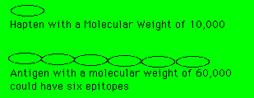
The antihapten antibody will react with the hapten with out the carrier protein molecule. Landsteiner demonstrated that virtually any chemical substance can serve as an antigenic determinant or epitope if conjugated to a suitable carrier. He also found that antibodies can distinguish between structural similar haptens. Antibodies recognize overall three-dimensional shapes of an antigenic determinant, rather than any specific chemical property.
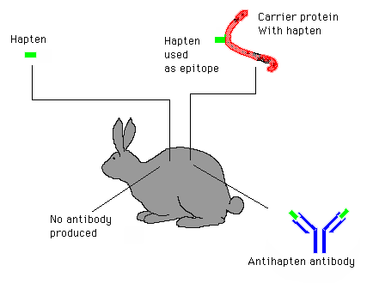
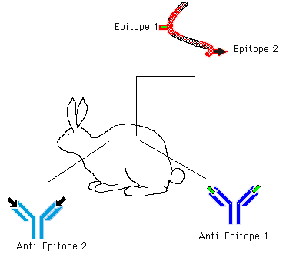
Epitope Characteristics
The paratope of an antibody that is specific for an antigen binds noncovalently to a region of the molecule know as the epitope. Naturally occurring epitopes are relatively small about four to six amino acids or sugar residues. The convex epitope area might be only 2 X 3 nm across. At these dimension epitopes can fit into the antigen binding site (paratope) of the antibody.
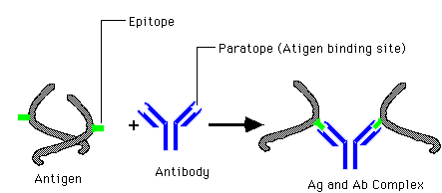

Large antigens (proteins or other macromoleculse) can possess many different epitopes on the same molecule. If an antigens has four different epitopes it could stimulate the production of four different antibody molecules with different paratopes. The antigen binding site (paratope) is concave pocket which match the convexity of the epitope. The paratope and epitope must come in close contact with each other since the binding forces are short (4 A) and weak.
Forces of the Antigen Antibody Reaction
The forces are hydrophobic, and Van der Waals forces which are spherical symmetrical. Hydrogen bonds are also involved which are directional and require matching reactants. Antigen and antibody reactions only take place when the epitope and paratope fit tightly.
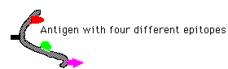
The hydrophilic regions of protein surface are the most likely to be antigenic; however the entire exposed surface could be antigenic. Normally the functional epitopes are exposed epitopes and are hydrophilic. These protruding parts of the molecular surface are generally most accessible to antibody molecules.
Some components of an epitope are more immunodominant than others. When the epitope is a terminal sequence, the terminal residue of that sequence is almost invariably the immunodominant subunit. Some amino acids contribute to the epitope more than others.
Some Amino Acids Are More Important Than Others
Since antibodies bind to antigen by noncovalent binding through charged groups and hydrophobic groups then amino acids like lysine and glutamic acid (charged amino acids) and alanine leucine, tyrosine, phenylalanine, and valine (hydrophobic amino acids) are important in the formation of the epitope.
Table 1 Abbreviations for amino acids.
_____________________________________________________________________________
Amino Acid Three-letter One-letter
abbreviation symbol
_____________________________________________________________________________
1 Alanine Ala A
2 Arginine Arg R
3 Asparagine Asn N
4 Aspartic Acid Asp D
5 Asparagine or aspartic acid Asx B
6 Cysteine Cys C
7 Glutamine Gln Q
8 Glutamic acid Glu E
9 Glutamine or glutamic acid Glx Z
10 Glycine Gly G
11 Histidine His H
12 Isoleucine Ile I
13 Leucine Leu L
14 Lysine Lys K
15 Methionine Met M
16 Phenylalanine Phe F
17 Proline Pro P
18 Serine Ser S
19 Threonine Thr T
20 Tryptophan Trp W
21 Tyrosine Tyr Y
22 Valine Val V
_____________________________________________________________________________

Amino Acid Structure
Physical Properties of Proteins
IpH of Proteins
Sequential and Conformational Epitopes
Epitopes whose specificity is determined by the sequence of subunits are designated sequential determinants. Sequential determinants can be composed of terminal or internal sequences of the antigen. Sequential epitopes are located in the hydrophilic part of the molecule.
Conformational determinants depend on the folding of the molecule. Conformational epitopes are normally associated with globular proteins and helical structures. Epitopes can be continuous or noncontinuous. Discontinuous epitopes are epitopes which are separated by amino acid sequence and are brought together by folding. Conformational epitopes are determinants which can be sequential discontinuous but sequential epitopes are always continuous.
Immunogenicity Immunogenicity refers to the relative ability of an antigen to stimulate the immune responses. In order for a molecule to be considered an antigen, it need only be capable of binding to a specific antibody molecule (or T cell receptor). Antigens that provoke the immune responses are immunogenic and can be called immunogens.
Characteristic of immunogens
1. Size 10,000 daltons or greater.
2. Foreignness
3. Molecular complexity
4. Concentration. Every antigen has an optimal immunogenic dose range. The amount of antigen can be quite critical. Too much or too little antigen might not elicit an immune response.
Adjuvants
The response to antigens can be increased by use of adjuvants. Ajuvants contribute to greater and prolonged antibody production and increased effector cell counts.
Ajuvants can react in several ways:
1. Alter the distribution and persistence of antigen within the host.
2. Stimulate lymphocytes production non specifically.
3. Activate macrophages.
4. Alter traffic of circulating lymphocytes.
Freund adjuvant consist of oil and Mycobaterium tuberculosis. This adjuvant can not be use in humans.
Routes of injection
1. Into the muscle (intramuscular IM)
2. Under the skin (subcutaneous)
3. Into a vein (intravenous IV)
4. Into the abdominal cavity (intrapeitoneal IP)
5. Into the skin (intradermal, Usually multiple injections)
Antigen presentation and epitope recognition.
Myeloma Protein
Antibody Structure
Five different Classes of Antibodies

Return
This page is maintained by the Natural Toxins Research Center at Texas A&M University - Kingsville.

