Cells, Tissue, and Organs of the Immune System

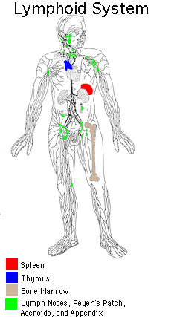

Organs of the immune system are shown. Primary organs are represented by upper case letter and are label in black. Secondary organs of the immune system are represented by lower case and are in red. Several lymph nodes are also lower case and are labeled in red.

Primary Lymphoid Organ
Tymus amd bursa of Fabricius
The thymus serves as a central lymphoid organ to control maturation of T cells which function in cell-mediated immunity. The bursa of Fabricius, in birds, is responsible for the antigen-in-dependent maturation of B cells involved in the humoral immunity. The bursa of Fabricius is a lymphoepithelial organ seen as an intestinal pouch in birds, but not in mammals. If the bursa Fabricius is removed, the birds will have normal cell-mediated immunity, but will not produce antibodies in response to an antigen. Both the thymus and bursa Fabricius atrophy at puberty. The mammalian equivalent of the bursa Fabricius appears to be the red bone marrow.
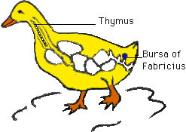

Bone Marrow
In adult animals, red bone marrow serves as the major source of all blood cell, including lymphocytes. The bone marrow is found in most bones including the skull, ribs, sternum femur, an spine. The distribution of red marrow diminishes with age. The bone marrow is the major site of hemopoiesis (production of red blood cells). Within the sinusoids are found blast cell which are the precursors of the different blood cells. Bone marrow contains various intermediate and mature forms of erythrocytes, monocytes, granulocytes, lymphocytes and megakaroyocytes.
Bone marrow is not only the source of all blood cell classes, but it provides the environment for the antigen-independent differentiation. of B cells. The bone marrow may provide an antigen-processing environment, as does the spleen.

Return
This page is maintained by the Natural Toxins Research Center at Texas A&M University - Kingsville.

