Complement

Complement. Serum proteins, found in the blood, along with cells of the immune system work together to eliminate foreign cells. Once activated, the complement system can bring about a variety of responses. This complement system consists of three separate activation triggers: (1) Ab binding to a cell surface, (2) formation of immune complexes, and (3) a carbohydrate component of a microbe's cell membrane. Along with this triggers, there are also two sets of mechanisms. Both of these mechanisms, classical pathway and alternative or properdin pathway, make MAC (Membrane Attack Complex), which can lyse and destroy the cell.
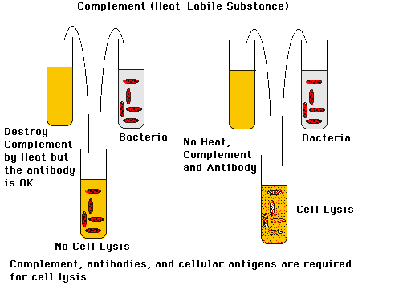
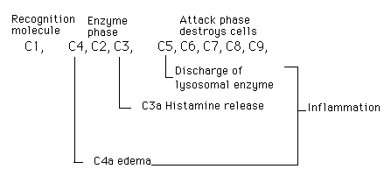
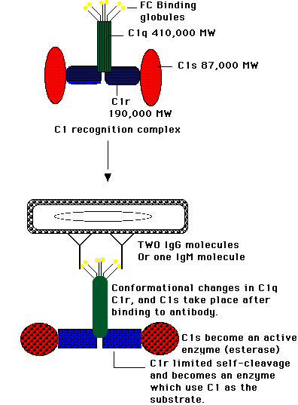
Structure of the C1 Molecule. The C1 protein is composed of three proteins: C1q, which binds to the Fc portion of the Ab molecule; C1s, which can enzymatically cleave the next complement component, C4; and C1r, which acts as a bridge connecting C1q to C1s.
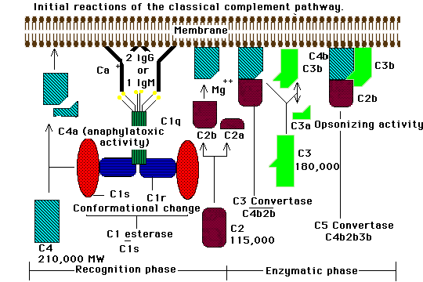
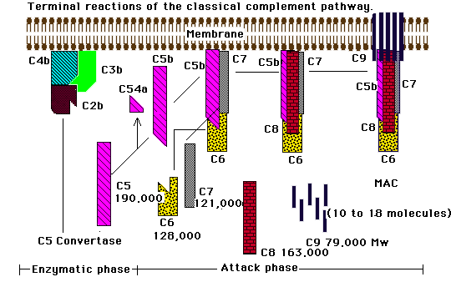
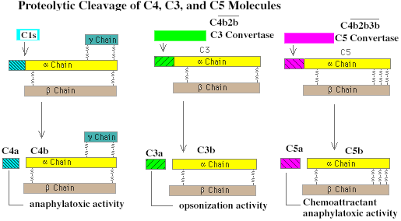
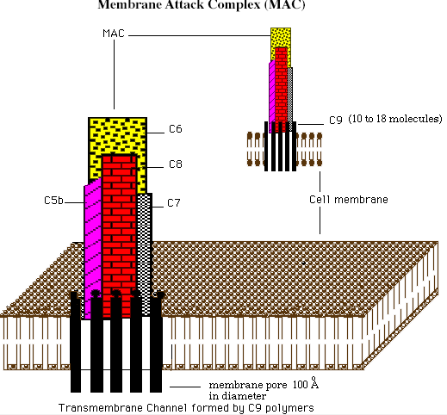
Classical Complement Pathway.
The classical complement pathway requires the presence of antibodies, either as immunoglobulin (IgG or IgM) bound to cell surface Ag or as an Ag-Ab immune complex. The serum protein C1 binds to the antibody, which in turn results in activation of C4, C2, and C3, and leads to the formation of C5, C6, C7, C8 and C9. This eventually leads to the formation of the C5-C9 membrane attack complex (MAC), which lyses and destroys the cell.
Found in the classical complement pathway are three phases or stages. These are (1) a recognition phase, during which the complement system becomes activated; (2) an enzymatic phase, which is characterized by amplification of complement activation; and (3) an attack phase, during which cell destruction actually occurs.
Recognition Phase. The recognition phase initiates the classical complement pathway when the inactive C1 serum protein interacts with the Fc portion of either cell-bound Ig (IgG or IgM) or an immune complex. Even though only one IgM-bound molecule is necessary to fix the C1 complex, two molecules of IgG bound in close proximity are required for activation to occur. This C1 recognition complex requires calcium to form the inactive unit, C1, which consist of one molecule of C1q and two molecules of each of C1r and C1s. When the Ab is bound, C1q connects with the Ab receptor sites located on the Fc portions of two adjacent Ab molecules. These sites are exposed when the Ab binds to the Ag. After binding to the sites, C1q undergoes a conformational change, which causes C1r to activate itself by limited self-cleavage. C1r now sees C1s as its substrate and activation of C1s gives rise to its ability to cleave the next two complement proteins, C4 and C2.
Enzymatic Phase Activation of C4 and C2 involves the cleavage of a specific peptide bond in each molecule, resulting in the dissociation of peptide fragments, C4a and C2a, and the exposure of a binding site in the larger fragment, C4b2b. The C4b peptide binds to the cell membrane, while C2b attaches itself to the C4b fragment. This C4b2b complex is enzymatically active, requires magnesium ions, and is called C3 convertase since it can bind and cleave the next inactive complement component in the sequence, C3.
Activation of C3 initiates the generation of a second convertase enzyme. This occurs when C3 is cleaved into C3a and C3b. The larger C3b fragment attaches to both the cell membrane and C4b2b complex, while the smaller fragment, C3a, is released to the body fluids. C4b2b3b is termed C5 convertase (or C3/C5 convertase), and its newly created catalytic site now accommodates C5, the next component in the sequence.
Attack Phase The attack phase begins when C5 convertase (C3/C5) cleaves C5 into two products, C5a and C5b. C5a is released when formed and C5b attaches to the cell membrane. The binding of C5b leads to the uncovering of a binding site for C6 and C7 on the molecule, producing a stable complex, C5b67, which attaches to the membrane surface and enables C8 to bind. C8, in turn, binds several C9 molecules. This stable complex is called C5b6789, or MAC.
The membrane attack complex (MAC) can produce a lesion in the plasma membrane causing cell lysis.
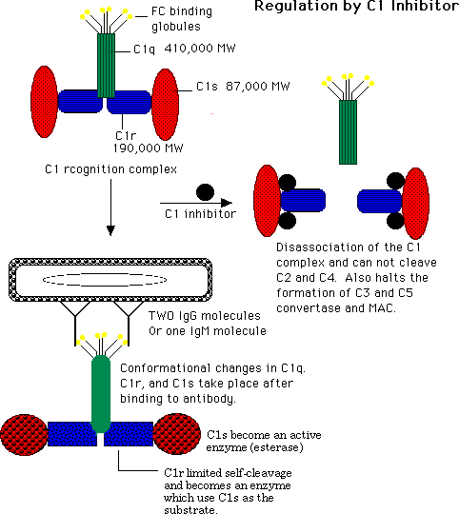
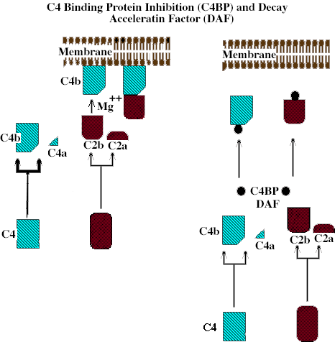
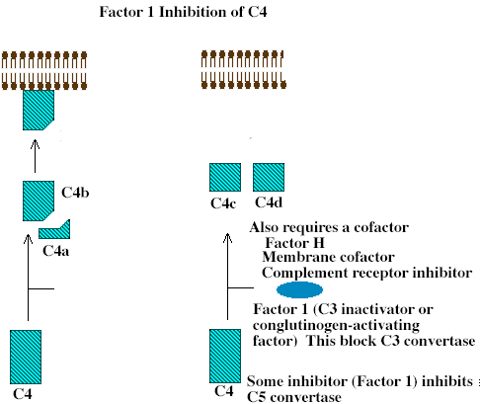
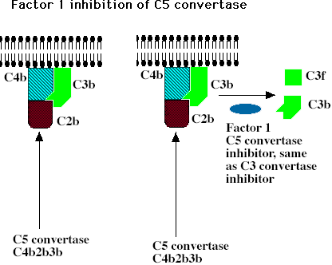
The classical complement cascade must be carefully regulated. The series of events must be of limited duration in order to prevent the complete consumption of inactive complement components in the serum. Each stage in this pathway contains regulatory proteins. The first stage of complement activation is the formation of recognition complex, C1. C1 inhibitor is responsible for the inactivation of C1. Its main function is to combine with activate C1 by binding to sites of C1r and C1s, causing these subunits to dissociate from Ab-bound C1q.
The inactivation of C3/C5 convertase is accomplished in two stages. The first stage consists of activity lost by dissociation of C2 from cell-bound C4. This is done by C4-binding protein (C4BP) and decay-accelerating factor (DAF). In the second stage, the generation of C3 convertase is blocked. This occurs through the further degradation of C4b into the inactive fragments C4c and C4d, and also by the cleavage enzyme, Factor I. Factor I requires a cofactor, these may be factor H and CRI.
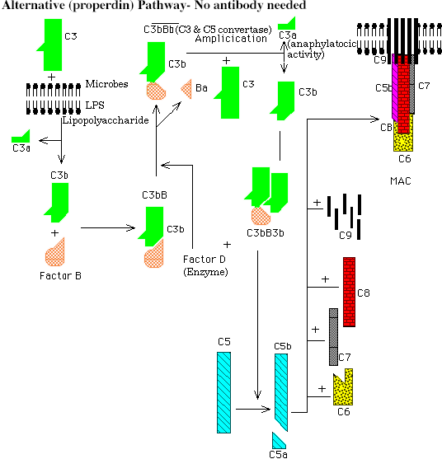
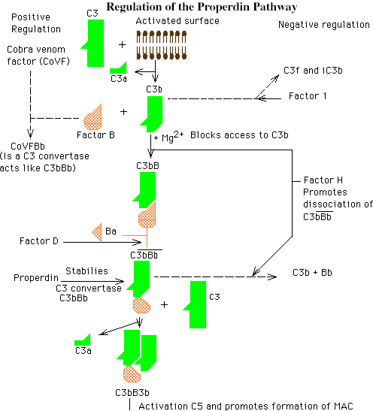
Alternative or Properdin Pathway
The alternative or properdin pathway can be initiated with the complete absence of antibodies. This pathway can be activated by nonimmune activators, for example, repeating polysaccharide units or the LPS found on the cell walls of some microbes. This alternative pathway differs from the classical pathway in that it has substitutes for the early acting C1, C4, and C2 components. Therefore, it can directly initiate the reactions of the late-acting C3-C9 components. It also differs in that it provides an immediate line of defense that does not require immunological memory.
This pathway is characterized by a two-phase system in which six proteins participate. Initiation is the first phase, particle-bound C3b acts like the C1 recognition complex. The second phase is called amplification, driven by a positive feedback loop involving bound C3b, Factor B, and Factor D.
Initiation Phase. C3 is a two-chain molecule, which upon cleavage, a highly reactive thiol-ester group is exposed on the C3b fragment. This reactive group could be attacked by water, by the surface of an organism, or by foreign substances to which it might bind. If the acceptor surfaces are chemically suitable, interaction with C3b can occur and the alternative pathway can be activated. C3b bound to foreign substances can interact with plasma protein Factor B, which is then cleaved into membrane-bound fragment Bb and soluble fragment Ba, through the action of an enzyme called Factor D. The C3bBb is a C3/C5 convertase.
Amplification Phase As C3bBb converts more C3 to C3b, the amplification process is initiated. This newly formed C3b binds more factor B. This positive feedback cycle continues until the membrane surface is saturated with C3bBb. The result is opsonization (enhanced engulfment) of the cell or particle by neutrophils. In addition, the soluble C3a that is released upon cleavage of C3 has anaphylatoxic activity, which can initiate an inflammatory response. The C3 convertase can bind additional C3b to produce C5 convertase (C3bBb3b), which, in turn, activates the terminal lytic complement sequence, C5-C9.
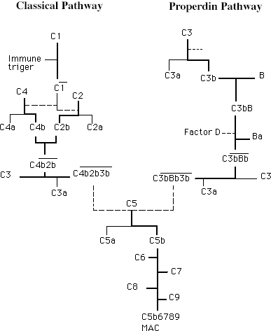
The activation of either the classical complement pathway or the alternative pathway leads to the formation of C3 convertase (C4b2b or C3bBb). Cleavage of C3 and binding of C3b to C3 convertases results in the formation of C5-converting enzymes (C4b2bC3b or C3bBb3b). At the end, both pathways form MAC, which mediates lysis of target cells.
Biological Consequences of Complement Activation
Complement activation not only causes cell lysis, but other effects as well. Some of these include: contraction of smooth muscle, release of histamine from mast cells and platelets, enhanced phagocytosis, chemotaxis of phagocytes, and activation of lymphocytes and macrophages.
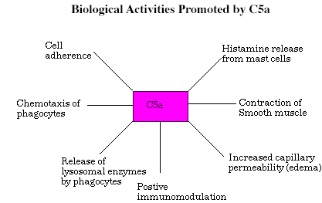
The main activity of C3a and C5a is anaphylaxis. These cause histamine release from mast cells and basophils, which can affect the activity of smooth muscle. Spasmogenicity, accounts for the ability of these molecules to induce an anaphylactic response in animals. In addition to spasmogenicity, histamine release induced by the anaphylatoxins as effects on inflammation. The cellular responses of neutrophils and monocytes to C5a include (1) degranulation and lysosomal enzyme release, (2) cell adherence, and (3) chemotactic migration.
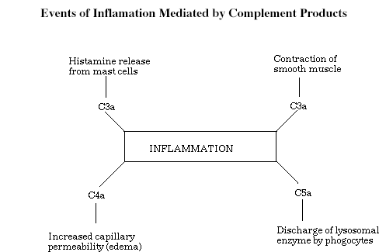
The acute inflammatory response is characterized by symptoms of redness, pain, swelling, and heat due to the action of C4a, C3a, C5a, and histamine. Inflammation's primary goal is to set into motion a series of events that result in the elimination of foreign and damaged cells. This response can be mediated by the anaphylatoxins and their byproducts.
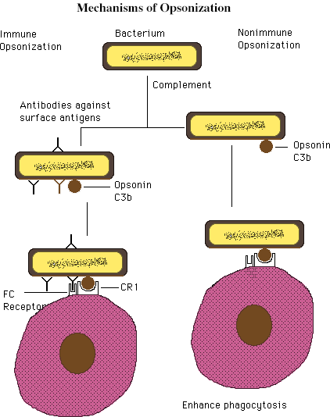
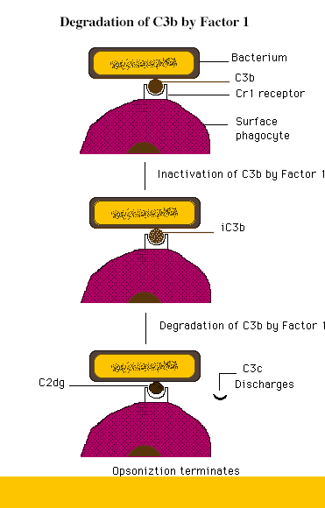
Opsonization. Facilitated phagocytosis is referred to as opsonization. In this process, C3b, which coats the particle, is known as an opsonin. This process occurs when cells, viruses, or immune complexes are made ready for enhanced phagocytosis by becoming coated with C3b or C4b. This leads to binding of bacteria to phagocyte C3 receptors and the subsequent clearance of the bacteria by phagocytosis. It can either take place in the presence or absence of antibodies.
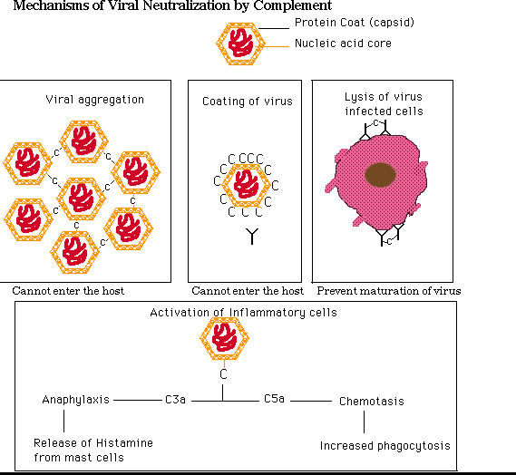
Complement -Dependent Viral Neutralization Part of the body's natural defense against viral attack is the production of antibodies, which can bind to the surface of the infecting virus. This, in turn, can activate complement, which could neutralize the virus. In fact, the complement system appears to play an important role in neutralizing viruses since it can be activated against certain viruses and virus-infected cells in the absence of antibodies.
Viral neutralization ban be accomplished by the complement system through four mechanisms: (1) viral aggregation, (2) coating of viral surfaces, (3) lysis of virally infected cell, and (4) activation of inflammatory cells.
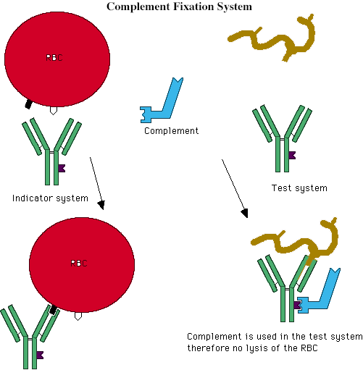
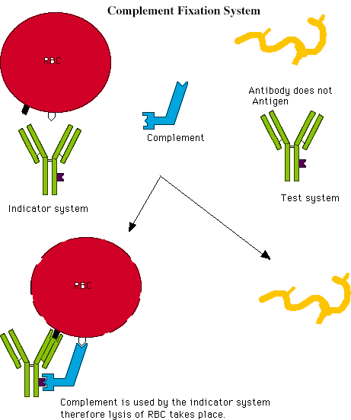
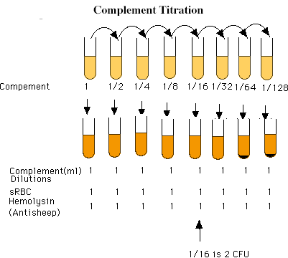
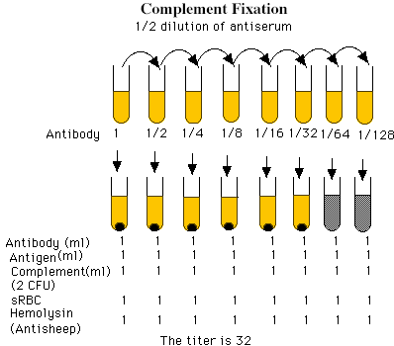

Return
This page is maintained by the Natural Toxins Research Center at Texas A&M University - Kingsville.

